Name
Teacher Resource Guide

Class of
2018



Everett Public Schools

8th to 9th grade Educational Planning Resource

2013-14 School Year

The purpose of this booklet is to help you prepare for
high school registration & post high school by assisting you:

- in connecting future career goals to your high school plan
- in understanding high school credits and requirements
- in developing your 9th grade schedule
- by providing sample 4-year course plan forms
- in knowing where to go for help and support

Table of Contents

Italicized titles indicate booklet worksheets

Preparation for high school page 5

Terms to know before you go ~ H.S. Vocabulary pages 6 – 7

H.S. Vocabulary Worksheet pages 8 – 9

H.S. College Readiness programs page 10

Planning Backwards Worksheet pages 11 – 12

Post High School Opportunities pages 13 – 14

Post High School Worksheet page 15

Education pays ~ Employment Projections page 16

Career preparation pages 17 – 18

High School Graduation Requirements pages 20 – 21

High School Graduation Requirements Worksheet page 22

Things to know before you go page 23

Calculate your GPA Worksheet page 24

High School Transcript page 25

Creating YOUR 4 year Plan Worksheet page 26

Sample 4 year Plan examples pages 27 - 31
Sample Freshman Schedules page 32

Tips for making your classes count page 33

Study Skills Worksheet page 34

Sequoia High School and Alternate credit options page 35

Jump start on high school page 36
Italicized titles indicate a student worksheet
Time Management Worksheet page 37

Time Management page 38

Extracurricular opportunities page 39

High School Concepts Worksheet page 40

High School Cyber Hunt Worksheet page 41

Preparation for High School








“Psst…it is what you have been doing
for the past 2 plus years of your life”

You have had a wide variety of experiences in middle school all designed to help YOU be ready for high school.

High school is about getting all the knowledge, skills, experience that will help you when you are OUT of school.

It is like having a cell phone…without a plan your phone won’t work and you won’t be able to call or text your friends or family …without a solid education and a high school diploma, life is … well like a cell phone that doesn’t get coverage, it won’t take you very far if you need to get a hold of someone.

This Blueprint was developed to help YOU plan for high school. It is not meant to take the place of your high school course planning guide. This Blueprint gives you GENERAL information to help prepare you for your journey. All schedules included in this booklet are samples and meant only to guide you as you create your 4-year plan. Your middle school counselor, your future high school counselor, your teachers, parents and high school websites can all help as you make decisions and preparations for high school. So make sure to use the tools available to you and to have fun as you GET READY FOR HIGH SCHOOL!

Terms to know before you go

ACT A college entrance test by American College Testing. Most 4-year universities require either the ACT or the SAT.

Advanced Special courses and exams given for specific H.S. subjects. Many
Placement (AP) colleges will award credit or waive requirements for demonstrated proficiency through these exams.

Alternate Additional classes that you register for just in case one of your non-core classes is full or will not fit into your schedule. For example, an alternate for Drawing & Painting might be Ceramics.

AR “Approval Required”. Some classes are designated AR which means you must have the teacher’s permission before you can sign up for the class.

AVID “Advancement Via Individual Determination.” AVID targets students in the academic middle who have the desire to go to college and the willingness to work hard. AVID provides an elective class that puts them on the college track.

Career and Technical Classes that prepare you for life after high school such as
Education (CTE) computer classes, marketing, or independent living. Many CTE classes offer opportunities for college credit.

Certificate of All WA state high school students must show they have key reading
Academic Achievement writing, math & science skills by graduation. Most students will meet
(CAA) this requirement, & earn the CAA, by passing state exit exams.

Closed Campus A campus where students are not allowed to leave, except in special circumstances, during the school day.

Credit What you earn for passing a class. One semester-long class earns 0.5 credit. You must earn 22 credits in order to graduate. You must also earn credit in specific subjects to graduate, for example, English and Math.

Culminating Required for graduation at all Everett district high schools. A culminating
Exhibition (CE) demonstration of learning and college and/or career planning including
the High School and Beyond Plan and Culminating Exhibition. Also called the “Sr. Project.”

Cumulative GPA Cumulative Grade Point Average. A number indicating the average of all the grades you have earned in all your classes. If you received all “A”s, your cumulative GPA would be 4.0.

Elective Any courses taken above the specified graduation requirements. For example: Fine Arts, Career and Technical Education, Math, Science, and World Language classes. Everyone needs electives to graduate. Select electives that interest you and fit your post-high school goals.

Fine Arts The fields of art in which you express yourself creatively, i.e. painting, drama and music. You must take Fine Arts classes to graduate.

GPA Grade Point Average- a number that indicates the average of the grades you receive. Most schools use a point system of 0 through 4. “A” equals 4, “B” equals 3, etc. If you took two classes and received an “A” and a “B”, your GPA would be 3.5.

PLAN The PLAN is considered a pre-ACT test. This test has both academic assessment components and an interest inventory that helps students identify possible career paths.

Prerequisite (Pre-Req.) A beginning class you must take and pass before you can take a more advanced one.

PSAT Preliminary Scholastic Aptitude Test. This test is good practice for the SAT. The Everett School District pays for all 11th graders to take the PSAT. It is also used to determine National Merit Scholars.

Rigorous courses Challenging yourself by taking higher level subject courses requiring pre-requisite skills, Advanced Placement (AP), Honors (H), and College in the High School (CHS).

SAT Scholastic Aptitude Test. The SAT is a college entrance test (also see ACT) that most students will be required to take before they go to a 4-year college/university. These scores are one of the criteria most colleges use to accept or reject applicants.

Senior Project See Culminating Exhibition

Smarter Balanced Tests A state graduation requirement designed to ensure students have a solid foundation of reading, writing, math and science. Based on the Common Core State Standards, students are required to pass English language arts (ELA) and math exit exams, and the Biology End of Course exam.

Transcript The official record of all your grades and credits.

Waiver Permission to be excused from taking a particular class.

Work Based A class allowing students to receive credit for work or volunteer
Learning (WBL) experience. If you have a job and meet specific requirements set by your school, you can receive credit toward your graduation requirements.

Student Vocabulary Worksheet
(to check student understanding) on next 2 pages

KEY
It’s Time to Check your VOCABULARY

Directions: Fill in the blank with the correct vocabulary word.
To assist, use the definitions on pages 6 & 7.
Cumulative GPA

___________________ A number that indicates the average of the grades you have earned in all of your high school classes. If you earned all “A’s,” this number would count as a 4.0.
PSAT

___________________ Preliminary Scholastic Aptitude Test. This test is good practice for the SAT. The Everett School District pays for all 11th graders to take the PSAT. It is also used to determine National Merit Scholars.
Fine Art

___________________ The fields of art in which you express yourself creatively, i.e. painting, drama and music. You must take this type of class to graduate.
Prerequisite

___________________ A beginning class you must take and pass before you can take a more advanced one.
Advanced Placement

___________________ Special courses and exams given for specific H.S. subjects. Many colleges will award credit or waive requirements for demonstrated proficiency through these exams.
Elective

___________________ Any courses taken above the specified graduation requirements. For example: Fine Arts, Career and Technical Education, Math, Science, and World Language classes. It is suggested that you elect to take such courses that interest you and fit your post-high school goals.
Waiver

___________________ Permission to be excused from taking a particular class.
SAT
___________________ Scholastic Aptitude Test. The test is a college entrance test that most students will be required to take before they go to a 4-year college/university. These scores are one of the criteria most colleges use to accept or reject applicants.
Transcript

___________________ The official record of all your grades and credits.
ACT
___________________ A college entrance test by American College Testing. Most 4-year universities require either this exam or the SAT.
Work Based Learning

___________________ A class allowing students to receive credit for work or volunteer
experience. If you have a job and meet specific requirements set by your school, you can receive credit toward your graduation requirements.
Career & Technical Educ. (CTE)

___________________ Classes that prepare you for life after high school such as
computer classes, marketing, or independent living. Many classes offer opportunities for college credit.
A.R.

___________________ “Approval Required”. Some classes are designed AR which means you must have the teachers’ permission before you can sign up for the class

KEY

High School Vocabulary Worksheet Continued
Culminating Exhibition (CE)

___________________ Required for graduation at all Everett district high schools. A culminating
demonstration of learning and college and/or career planning including
the High School and Beyond Plan and Culminating Exhibition. Also called the “Sr. Project.”
Closed Campus

___________________ A campus where students are not allowed to leave, except in special circumstances, during the school day.
Credit

___________________ What you earn for passing a class. You must earn 22 of these in order to graduate. You must also earn these in specific subjects to graduate, for example, English and Math.
Alternate

___________________ Additional classes that you register for just in case one of your non-core classes is full or will not fit into your schedule. For example, an alternate for Drawing & Painting might be Ceramics.
PLAN

___________________ The practice exam is considered a pre-ACT test. This test has both academic assessment components and an interest inventory that helps students identify possible career paths.
Rigorous Courses

___________________ Challenging yourself by taking higher level subject courses requiring pre-requisite skills, Advanced Placement (AP), Honors (H), and College in the High School (CHS).
GPA

___________________ A number that indicates the average of the grades you receive. Most schools use a point system of 0 through 4. “A” equals 4, “B” equals 3, etc. If you took two classes and received an “A” and a “B”, your GPA would be 3.5.
AVID

___________________ “Advancement Via Individual Determination.” This program targets students in the academic middle who have the desire to go to college and the willingness to work hard. This program provides an elective class that puts students on the college track.
Certificate of Academic Achievement (CAA)

___________________ All WA state high school students must show they have key reading
writing, math & science skills by graduation. Most students will meet
Smarter Balanced Tests
this requirement & earn this certificate by passing state exit exams.

____________________ A state graduation requirement designed to ensure students have a solid foundation of reading, writing, math and science. Based on the Common Core State Standards, students are required to pass English language arts (ELA) and math exit exams, and the Biology End of Course exam.

Maximize your College Readiness in High School

If you are interested in learning more about any of the below programs,
talk with your middle or high school counselor.

Directions: Put a star “" next to any program(s) you would like to learn more about or take when you are in high school.

Advanced Placement (AP): The Everett Public Schools AP program was designed to develop rigorous, college-level courses and assessments for high school students. Through AP courses, students demonstrate and confirm their mastery of particular subjects through AP exams. AP exams are offered each spring, and are open, for a fee, to any student.

AVID: “Advancement Via Individual Determination.” AVID is a class designed for students who are in the academic middle and who desire to attend a four year college. Students learn a variety of study, reading, and writing strategies. Students are expected to use these strategies in their other classes and to enroll in the most challenging course of study that is suitable to their skills. Enrollment is by invitation and application. Applicants are selected based on a person interview.

Career and Technical education (CTE): Classes that prepare you for the work force after high school, and classes that give you practical skills for everyday living. These classes are offered at each high school. Some CTE classes offer opportunities to earn college credit.

College-in-the-High-School classes: The High Schools in Everett Public Schools contract with the University of Washington and area community colleges to offer courses taught by high school staff on the high school campus. To earn both high school and college credit, students pay tuition (at a reduced rate) and receive both high school and college credit.

Running Start: This is a program which allows high school juniors and seniors with at least 10 credits to attend community college tuition FREE. Students receive both high school and community college credits for these courses. You must provide your own transportation and purchase your books and materials. You also must take the community college entrance exam and test into college-level English.

Sno-Isle: The Sno-Isle Skills Center is a vocational school located near Paine Field and offers over 19 different career/vocational programs. Sno-Isle offers awards and scholarships for top students. Students may attend during their junior and/or senior year as part of their daily schedule of classes. Transportation is provided from each high school.

Tech Prep: Certain high school career technical education courses are aligned with the curriculum at the community colleges. By taking such courses, students can earn high school and community college credits at the same time.

Work Based Learning: This class teaches employability skills by having each student maintain a job at local work site and by meeting with the teacher each week.
Planning Backwards

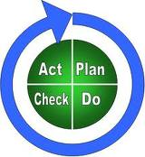

High school is an opportunity for you to lay the foundation for the rest of your life. High school is really only a continuation of what you have already been working on in elementary and middle school.
Step #1
Think about the WOIS interest survey (www.wois.org) you took earlier this year. After you completed the survey, you were given a list of careers that you might enjoy based on the way you answered the questions. Having investigated at least 3 of the careers that were either suggested by Bridges, or those that you absolutely KNOW what you’d like to do, ask yourself: Do these careers still interest you?
Then, star () the career that most interests you.
Still interested?
Career #1 _____________________________ Yes No

Career #2 _____________________________ Yes No

Career #3 _____________________________ Yes No
Step #2

Based on your reflection…
In one sentence, state how you feel about the career you marked with a star ().
EXAMPLE: I enjoyed learning that I should get a job working with people, because I enjoy helping others.
EXAMPLE: I was surprised to learn that I would be good in science related careers,
because I haven’t thought about such careers before.

________________________________________________________________

________________________________________________________________
Step #3
This worksheet is in reference to M. S. Counselor Career Activities & WOIS work with students.
Student driven answers will vary.
Thinking about your starred () career, what types of high school classes do you think would be helpful for you as you prepare for this career?

EXAMPLE: to be a math teacher, I’ll need to take math classes.
EXAMPLE: to work with computers I’ll want to take several computer classes.

_________________ _________________ _________________

_________________ _________________ _________________

If you aren’t sure what you want to do (or do not even have an idea) you can think about it this way…what OPPORTUNITIES would you like to have after high school?
EXAMPLES: I would like to travel. I would like to work with animals.

There are a number of “doors you can walk through” once you finish high school.
Step #4


Technical & Trade
Program

Community College

Military

On-Job
Training
Apprenticeship

Work

4-year College

Each door offers YOU valuable opportunities. It is important to know that each door has certain requirements to open it. Considering (or knowing) which door you want to open will help you use your high school years for preparation. It is always a smart idea to aim high. If you are not entirely sure what you would like to do after high school, no problem. It is smart to have many opportunities or “doors” available to you, so plan to take rigorous classes. If you take the requirements that will make you eligible to go to a 4-year college, you will very likely be able to go through any of the doors shown above.

Which “door” would you like to be able to open after high school?

___________________________________________________________________

Why?

___________________________________________________________________

If you don’t know exactly which door looks most inviting, what might you do or who might you talk to, to explore this question further?

___________________________________________________________________

Who do you know who has a career that interests you? You should interview that person about their career path. Talking to people is an EXCELLENT way to find out more about the path you need to take.
Who could you interview? ____________________________

Post HS Opportunites

Technical & Trade

Colleges

- 1 to 2 year programs

- There is a huge need for skilled high tech workers in the United States and many people decide to attend a technical school, technical institute, or technical college to prepare for a high paying job in the high tech industry.

- Examples: ITT tech in Everett, Lake Washington Institute of Technology in Kirkland


Community

Colleges

- 3 types of degrees & certificates: academic transfer degrees, professional-technical degrees, and certificates of achievement.

- Earning an academic transfer degree is basically the same thing as completing the first 2 years at a 4-year college/university.

- Majors are offered in many academic, scientific, and technical fields. In most fields, if you plan to transfer to a 4-year college/univ., you work toward an Associate in Arts (A.A.) or Associate in Arts & Sciences (A.A.S.) degree, which requires 90 college-level credits. Once you complete a community college degree you can apply to a 4-year college where you can earn a higher degree.



Military Service

There are a number of ways to
be involved with military service
after high school. Benefits include:
- Educational opportunities include up to 90% tuition assistance for college courses taken during off-duty time
- Free technical training in over 200 skill areas
- G.I. Bill-Tuition for any school

Requirements: Entrance requirements are high for all branches of the service, but do differ among the individual branches. Each service has its own recruiters who will determine eligibility of applicants for specific training and assignments. Eligibility basics:

- Be a high school graduate
- Be at least 17 years of ages (under 18 requires permission of parents)
- Be physically qualified
- Be of good moral character
- Qualify on the Armed Services Vocation Aptitude Battery (ASVAB)

Four-Year Colleges

& Universities

- 4-year colleges & universities offer you the widest variety of class subjects and levels, from art to zoology and from introductory to advanced.

- The degrees available from a 4-year college or university are: Bachelor of Arts degree (B.A.) in many fields of study. The Bachelor of Arts in Business Administration (B.A.B.A.) is also available. Bachelor of Science degrees (B.S.) are offered in technical fields such as computer science, forestry, medical technology, engineering, and nursing.

- A university (as opposed to a college) also offers master’s degrees (M.A., M.S.) and doctorates (Ph.D.) for advanced, highly specialized study.




This gives more information on the “doors” on pg. 12

Internship

- An intern is an advanced
student or a recent graduate undergoing supervised practical training.

- Internships motivate students to select the right courses, and make learning in high school a priority. Students benefit from seeing real-life applications of the skills they are learning in school.

- An internship is a fantastic way to “try on a job” before deciding on a career.

- Internships may be offered in any field, including manufacturing, health care, banking and finance, travel and hospitality, communications and construction.

Apprenticeship

- An apprenticeship is a training program where you earn wages while learning a skilled profession in a specific field.
- Examples: construction (carpenters, electricians, plumbers, sheet metal workers, etc.), culinary arts, health care
- Apprenticeships are supervised by a trade professional and combine both classroom studies and on-the-job training.
- It can take several years to become fully trained in the occupation. As an apprentice you earn a salary while you learn about your trade. Once you’ve completed your training, you earn the same wages as a professional.


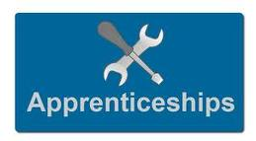

Consider this- if you are a high school student thinking about college: Someone with a: bachelor's degree earns nearly $1 million more over his or her lifetime than a high school graduate. A Census Bureau survey shows a full-time worker (who works what demographers call a typical work-life period, between ages 25 – 64) will expect to earn:

College graduate Master's degree Professional degree,
(Such as a doctor or lawyer)

$2.1 million $2.5 million $4.4 million



KEY
It’s Time to Check your Understanding of POST-H.S. OPTIONS

Directions: Answer each question. To assist, use the information covered on pages 10 - 14.

- Identify 6 post high school opportunities:
Tech. & Trade Schools

Community College

Military
Internship

Apprenticeship

4-Year College/Univ.

1. 4.

2. 5.

3. 6.

- An ___internship____ is a fantastic way to “try on a job” before deciding on a career.

- The ___Sno-Isle _ ___Skills __ Center is a vocational school located near Paine Field and offers over 25 different career/vocational programs.
- Earning an ___academic ___ __transfer___ degree is basically the same thing as completing the first 2 years at a 4-year college/university.

- ___Running ___ ____Start ___ is a program which allows juniors & seniors with at least 10 credits to attend community college tuition FREE.

- You must be a high school graduate in order to join the military? True False

- What are two options for earning college credit during high school?
College in the H.S. Tech Prep

Running Start
1.

2.

- An apprenticeship is a training program where you earn wages while learning a skilled profession in a specific field. Name 2 apprenticeship program examples:
Construction Health Care

Culinary Arts
1.

2.

- Name the 3 types of degrees & certificates offered through a community college:
Academic Transfer Degrees

Professional-Technical Degrees

Certificate of Achievement
1.

2.

3.

- Name two of our local Technical & Trade Schools:
ITT Technical in Everett

Lake WA Institute of Technology in Kirkland
1.

2.
Hey, did you know…
Education Pays!!



Why go to college?

Can’t I get a good job now? Yes, maybe you could, but a college degree will make your chances even better. Check out the earnings and unemployment rates for people 25 years and older with different levels of education:
Level of education completed | Mean (average) earnings in 2011 | Unemployment rate in 2011
Less than a high school diploma | $29,848 | 14.1%
High school graduate, no college | $41,288 | 9.4%
Some college, no degree | $46,288 | 8.7%
Occupational program (career school) | $49,920 | 6.6%
Associate degree (academic program) | $52,988 | 6.9%
Bachelor’s degree | $71,552 | 4.9%
Master’s degree | $84,448 | 3.6%
Doctoral degree (e.g., Ph.D.) | $102,648 | 2.5%
Professional degree (e.g., M.D., J.D.) | $121,212 | 2.4%

Source: Bureau of Labor Statistics, Current Population Survey, unpublished tables, 2012.

Just in case you were wondering

Career Preparation
All jobs require some sort of preparation. Below are some popular job titles and the preparation/training they require (along with the average wage earned per year).

Abbreviations:
OJT = On the Job Training CC = Community College
HS = High school diploma or equivalent 4 = 4 year college/university
T = Tech program or trade school 4+ = Masters or Ph.D.
App = Apprenticeship 4++ = professional degree plus certification

Little Preparation (Less than one month OJT through CC)

Occupation Title Training Mean Wages
Combined food service workers, including fast food OJT $25,500
Cashiers, except gaming OJT, HS $27,000
Retail sales OJT $32,000
Waiter, waitress OJT $30,000
General office clerk OJT, HS, CC $35,500
Child care workers OJT, HS, CC $22,000
Laborers and freight/stock handlers OJT, HS $32,500
Counter and rental clerks OJT $27,000
Janitors and cleaners, except maids OJT, HS $28,500
Maids and house cleaners OJT $25,000
Receptionists and information clerks OJT, HS, CC $33,000
Counter attendants, cafeteria and food concessions OJT $23,000
Landscaping and grounds keeping workers OJT, HS, T $35,000
Stock clerks OJT, HS $31,000
Teachers Assistants OJT, HS, CC $29,000

Short Preparation (1 to 12 months OJT, plus some tech, CC, or App)

Occupation Title Training Mean Wages
Sales representatives, non-tech or non-science manufacturing OJT, HS, 4 $60,000
Painters, construction and maintenance OJT, HS, App, CC, T $40,500
Bookkeeping, accounting and audit clerks OJT, HS, CC, 4 $42,000
Secretaries, general office OJT, HS, CC $40,000
Customer service representatives OJT, HS $37,000
Sales representatives, tech and science manufacturing OJT, HS, 4+ $70,000
Executive secretaries and administrative assistants OJT, HS, CC, 4 $45,000
Medical assistants OJT, HS, CC, 4 $32,500
Bus drivers, city transit OJT, HS $39,000
Dental assistants OJT, HS, CC, T $45,500
General farm, fishing and forestry laborers OJT, HS, CC, T, 4 varies
Truck drivers, tractor-trailer OJT, HS, T $42,500
Team assemblers OJT, HS, T, CC $33,000
Construction laborers OJT, HS, T, CC $47,000

Career Preparation Continued

Middle-Level Preparation (1 to 4 years training through employer, CC or 4-year degree, or
combinations of these. All require high school graduation and OJT.)

Occupation Title Training Mean Wages
Registered Nurses 4+ $66,000
Hairdressers, stylists, cosmetologists CC, T $42,000
Managers of construction trades, first-line managers CC, App, 4+ $70,500
Carpenters CC+, App, T $52,500
Automotive service mechanics CC, T $45,000
Managers of office and Admin support workers CC, T $55,500
Managers of retail sales workers CC+ $49,500
Medical secretaries CC+ $35,500
Real estate sales agents CC, 4+ $55,500
Managers of food preparation workers CC, 4+ $42,000
Cooks, restaurant CC+ $30,000
Maintenance and repair workers CC, T $42,000
Electricians CC, App, T $60,000
All other managers CC+, 4+ $85,000
Licensed practical Nurses and vocational nurses CC+, 4 $43,500

More preparation (Completion of 4-year college degree or higher. May require additional professional
degree or license, plus work experience)

Occupation Title Training Mean Wages
Business operations specialists 4+ $67,000
College professors 4++ $69,500
Aerospace engineers 4++ $81,000
Elementary teachers 4+ $49,000
Insurance sales agents 4+ $60,000
General operations managers 4+ $107,000
Accountants and auditors 4+ $70,000
Management analysts 4+ $75,000
Physician and surgeons 4++ $125,000
Secondary teachers 4+ $52,500
Stock agents (securities and financial sales) 4+ $80,000
Computer systems analysts 4+ $75,500
All other teachers 4 $45,500
Middle school teachers 4+ $45,500
Construction managers 4 $80,000


Now, that you have considered career opportunities,
let’s take a CLSER look at the next 4 years of your life, & how it impacts future opportunities

There are 4 high schools in the Everett Public School system: Cascade High School, Everett High School, H. M. Jackson High School, and Sequoia High School. Each one has the same requirements; however, it is important that you know each high school has varying course options.

To plan for your high school education, it is important for you to understand…

- What you plan to do after high school
- How many credits you need to graduate
- Which classes you are required to take to graduate
- Other graduation requirements
- How to calculate your GPA
- How to meet standard on the Reading, Writing, Math and Science portions of the Smarter Balanced Tests and Exit Exams

Earning credits
You must earn 22 credits to graduate from an Everett Public High School. You get these credits by passing classes. A semester class equals 0.5 credit (½ credit). By passing a whole year class (for example, English) you will earn a total of one credit (1.0 credit).

It is important that you keep up with your assignments, prepare for tests and quizzes and ask for help before you get behind. If you fail a class you will not earn credit and you will have to retake the class if it is a graduation requirement.

EARNING CREDITS IS CRITICAL!

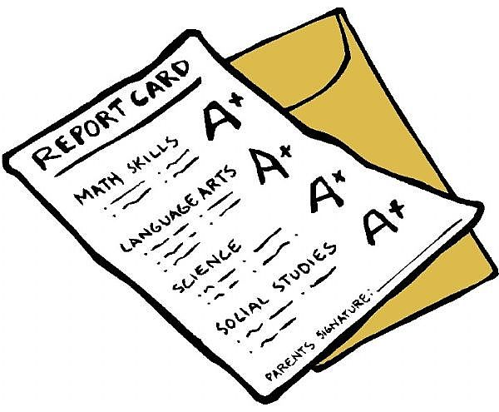
Graduation Requirements
(Required Classes)

CLASSES REQUIRED TO GRADUATE CLASSES REQUIRED TO
FROM HIGH SCHOOL GRADUATE AND
ATTEND A 4 YEAR COLLEGE

The required classes for you to take in order to graduate from high school are:

- 4.0 English credits
- 3.0 Social Studies credits
  - 1.0 World History
  - 1.0 U.S. History
  - 0.5 Government
  - 0.5 Washington State History credit or Soc. Studies Elective (If you passed WSH in middle school)
- 1.0 Fine Arts credit
- 1.5 Physical Education credits
- 0.5 Health credit
- 3.0 Math credits
- 1.0 Career & Technical Education credit
- 2.0 Science credits
- 0.5 Senior Seminar credit
- 5.5 Elective credits
- Senior Quantitative Elective**

Total 22.0 credits

The required classes for you to take in order to graduate & attend a 4-year college are:

- 4.0 English credits
- 3.0 Social Studies
  - 1.0 World History
  - 1.0 U.S. History
  - 0.5 Government
  - 0.5 Washington State History credit or another Social Studies* credit
- 1.0 Fine Arts credit
- 1.5 Physical Education credits
- 0.5 Health credit
- 4.0 Math credits/Alg-Trig level or higher
- 1.0 Career & Technical Education credit
- 3.0 – 4.0 Science credits
- 0.5 Senior Seminar credit
- 2.0 or more Elective credits
- 2.0 or more World Language credits

Total 22.0 credits

*Check your high school Planning Guide to find out what social studies classes they
offer.

** To align with the Washington State Student Achievement Council College Admission Standards, students must earn 1.0 credit in a mathematics-based quantitative course during the senior year of high school. This requirement may be met by earning credit in one of the three required mathematics courses; or earning credit in a mathematics-based quantitative course like Statistics, Applied Mathematics, or appropriate career and technical courses; or by earning credit in an Algebra-based Science course taken during the senior year. Completion of higher-level mathematics prior to the senior year fulfills this requirement (e.g., Pre-Calculus, Mathematics Analysis, or Calculus).
Reference this page with the credit lesson

The course Planning Guide for each high school will explain the SPECIFIC REQUIREMENTS for that school and how to account for your credits.
Graduation requirements in addition to classes

- Meet standard on the Smarter Balanced Tests in English Language Arts, Math & Science
- Meet standard on your Culminating Exhibition


Smarter Balanced Tests and Exit Exams

A state graduation requirement designed to ensure students have a solid foundation of reading, writing, math and science. Based on the Common Core State Standards, students are required to pass English Language Arts (ELA) exit exam, one of two math exit exams, and the Biology End of Course (EOC) exam, or a state-approved alternative.

A Certificate of Academic Achievement (CAA): is earned by meeting standard on:
- the English Language Arts Exit Exam or 11th-grade Smarter Balanced ELA Test,
- the Algebra 1 or Geometry EOC Exit Exam or 11th-grade Smarter Balanced Math Test,
- and the Biology EOC or Comprehensive Next Generation Science Standards (NGSS) Test.

State approved assessments are required for high school graduation.



For more information, please review the OSPI website:
www.k12.wa.us/assessment/Smarter/default.aspx


Culminating Exhibition and the High School & Beyond Plan
(also called: “Senior Project” or “CE”)
The Culminating Exhibition is required for graduation from all of the high schools in this district. Students have an opportunity develop a project that demonstrates application of knowledge and may include research, learning a new skill, writing a paper, and presenting the project to a review panel. This is an opportunity to have support and mentorship as you explore a topic, a career or a personal interest. It is also through this class that students complete their required High School and Beyond Plan.

For more information, please review the EPS website:

http://everettce.com/
KEY
It’s Time to Check your Understanding of
GRADUATION REQUIREMENTS

Directions: Answer each question. To assist, use the information covered on pages 16 - 21.

- In addition to earning credits, name two other things you need to pass in order to graduate from high school:

1. Smarter Balanced Tests & Exit Exams

2. Culminating Exhibition & the HS & Beyond Plan

- Name one high school graduation requirement you can complete in middle school:
WA State History, Algebra 1, Geometry, Coord. Science

- If you fail a class, you will still earn credit for the course. True False

- From the list on pages 17 & 18, name a job that interests you: (See pg 17/18)

What type of training is needed? __________________________

What is the average wage? ______________________________

- Do you need a world language…

… to graduate from high school? Yes No

… to enter a 4-year college/university? Yes No

- You need to earn ____22___ credits to graduate from a high school in the Everett School District.

- You need to earn ___4.0___ English credits to graduate from high school.

- You need to earn ____3_____ math credits to graduate from high school.

- You need to earn ____1_____ fine arts credits to graduate from high school.

- To enter a 4-year College/University, a student needs to complete

____2____ World Language credits, _____4_____ English credits,

___4_____ Math credits, and ____3_____ Social Studies credits.

Things to know before you go
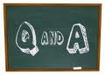


Grades:
Freshmen grades DO count!
- Your grades throughout high school impact your future options.
- Your GPA does not start over each year.
- If you fail a class, you don’t get any credit and it doesn’t count toward your graduation. That failure will affect your transcript during your entire high school career, even if you take the class over and get a better grade.
- Note: When you apply to college, the GPA you submit is often based on your first 3 years - 9th, 10th and 11th grade of high school. 9th grade or your freshman year is 1/3 of your GPA used when applying to college. Colleges will see your senior transcript and GPA as well, so senior year is also extremely important.


Attendance:
There are important reasons to attend your classes. Too many absences can cause the following:
  - Potential loss of credit
  - Inability to take electives
  - Inability to participate in sports, Sno-Isle, Running Start, etc.
  - Inability to qualify for open campus

You need to be IN class to LEARN. Get a pre-arranged absence form from the school website or Attendance Office, fill it out, and turn it in to the Attendance Office before any planned absences. A parent/guardian must excuse your absence with the school attendance office within 2 days of the absence.


Changing your Schedule:
  - You may make changes to your schedule ONLY during the first 10 days of a semester, and ONLY if you have an error on your schedule. See your school’s schedule change policy for more information.
  - If you drop a class AFTER 10 days you will receive an F for that class.
  - Make sure to talk to your counselor if there is a problem with your schedule.
  - You may not drop a class that is a requirement for graduation.
  - You cannot change your schedule based on teacher preference, your lunch, or to get into a class with a friend.

How to calculate your GPA


Your Grade Point Average (GPA) is the average of all your class grades that reflects your academic performance. GPAs are used in determining athletic and academic scholarships, college admissions, entrance to special programs, and work opportunities.

The grade you get for each class has a point value. The point value follows the point system:

A = 4.0 points
This is a good page to use the “GPA Trajectory” lesson
A- = 3.7 points
B+ = 3.3 points
B = 3.0 points
B- = 2.7 points
C+ = 2.3 points
C = 2.0 points
C- = 1.7 points
D+ = 1.3 points
D = 1.0 points
F = 0.0 points*

*“F” indicates a failing grade and is included in your GPA

To calculate your GPA, take the total number of points you have earned and divide those points by the number of classes you’ve taken.

Just for fun, calculate your CURRENT GPA!

What is your CURRENT GPA for this trimester? __________

Is this the GPA you want to earn? YES NO

If “yes”, what are you doing to earn it? ____________________________________

If “no”, what could you do to earn a higher GPA? ____________________________

The High School Transcript used by all
Public Washington State High Schools

A transcript is a paper that summarizes your classes, grades and cumulative GPA. Colleges use your transcript to review your academic career and potential. Employers may use it to get a sense of what kind of employee you will be. The National College Athletic Association (NCAA) uses it to determine recruitment eligibility. Your transcript reports your classes and your grades.
Your name, student ID, & parent/guardian name
Grade Point Table
The high school name & address

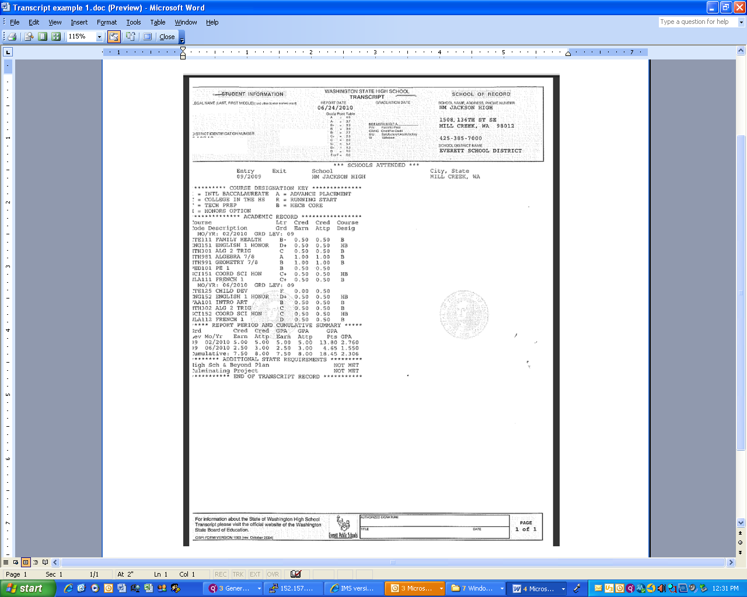
This section lists all of the high schools a student has attended
1st semester classes, grades & credits earned
2nd semester classes, grades & credits earned
Cumulative credits earned
Cumulative GPA
Middle School Alg. 1 & Geom. can be added to your H.S. Transcript
NOTICE: If you fail a class, you won’t earn credit
This page is also linked to the JHS Counseling Webpage at:

http://www.everettsd.org/Page/9411

Creating YOUR 4-year High School Plan

Use the charts on the following pages, along with your future high school (Cascade, Everett, Jackson, or Sequoia High School) Planning Guide to create your 4-year high school plan for high school graduation. On pages 27 – 32 you will find sample 4-year plans for college, college with band or choir, vocational prep, and vocational tech 4-year college plan. Remember, this is a “living” document; you should make updates to it throughout your high school career.

9th grade, Semester 1 9th grade, Semester 2
1. English 1 | 1. English 1
2. Science | 2. Science
3. Mathematics | 3. Mathematics
4. PE | 4. Health
5. | 5.
6. | 6.

10th grade, Semester 1 10th grade, Semester 2
Step #1 – Fill in worksheet

Step #2 – Computer lesson: Input your H.S. & Beyond Plan & your 4-year course plan online.

The HAC PowerPoint lesson information is located on pg. 52 of this booklet.

Have students save their plan and print a copy for the 8th grade transition meeting folder.
1. English 2 | 1. English 2
2. Science | 2. Science
3. Mathematics | 3. Mathematics
4. World History | 4. World History
5. | 5.
6. | 6.

11th grade, Semester 1 11th grade, Semester 2
1. English 3 | 1. English 3
2. U.S. History | 2. U.S. History
3. Mathematics | 3. Mathematics
4. | 4.
5. | 5.
6. | 6.

12th grade, Semester 1 12th grade, Semester 2
1. English | 1. English
2. WA State (unless you passed this in M.S.) or another Social Studies | 2. Government
3. Senior Seminar (CE) | 3.
4. | 4.
5 | 5.
6. | 6.
My 4-year High School Schedule - College
What Career are you currently considering? | What training/education will you need in order to obtain this position? | What qualifications (HS classes, etc) will you need to get into this training/education? | What classes should you take in HS to make sure you are qualified to enter this training/education institution? | What other activities should you include in order to prepare you for your future?

9th grade, Semester 1 9th grade, Semester 2
1. English 1 or Honors | 1. English 1 or Honors
2. Coordinated Science or Honors | 2. Coordinated Science or Honors
3. Algebra, Geometry, or Alg. 2 | 3. Algebra, Geometry, or Alg. 2
4. PE | 4. Health
5. Fine Arts | 5. Career & Technical Education
6. World Language | 6. World Language

10th grade, Semester 1 10th grade, Semester 2
1. English 2 or Honors | 1. English 2 or Honors
2. Biology or Honors | 2. Biology or Honors
3. Geometry, Algebra 2, or Pre-Cal | 3. Geometry, Algebra 2, or Pre-Cal
4. World History or AP | 4. World History or AP
5. Career & Technical Education | 5. Fine Arts
6. World Language | 6. World Language

11th grade, Semester 1 11th grade, Semester 2
1. English 3 or AP | 1. English 3 or AP
2. U.S. History or AP | 2. U.S. History or AP
3. Algebra 2, Pre-Cal, or Calculus | 3. Algebra 2, Pre-Cal, or Calculus
4. Chemistry | 4. Chemistry
5. PE | 5. Elective
6. World Language | 6. World Language

12th grade, Semester 1 12th grade, Semester 2
1. English – English 4, UW, AP, etc. | 1. English - UW, AP, Myth/Legend, etc.
2. WSH or other Social Studies | 2. Government or AP
3. Pre-C, Stats, Cal, AP Stats, or AP Cal | 3. Pre-C, Stats, Cal, AP Stats, or AP Cal
4. Physics, AP Bio, AP Chem, AP Physics | 4. Physics, AP Bio, AP Chem, AP Physics
5. Sr. Seminar (CE) | 5. Elective
6. PE | 6. Elective

My 4-year High School Schedule - with Band, Choir or AVID

What Career are you currently considering? | What training/education will you need in order to obtain this position? | What qualifications (HS classes, etc) will you need to get into this training/education? | What classes should you take in HS to make sure you are qualified to enter this training/education institution? | What other activities should you include in order to prepare you for your future?

9th grade, Semester 1 9th grade, Semester 2
1. English 1 or Honors | 1. English 1 or Honors
2. Coordinated Science or Honors | 2. Coordinated Science or Honors
3. Algebra, Geometry, or Algebra 2 | 3. Algebra, Geometry, or Algebra 2
4. PE | 4. Health
5. Band/Choir/AVID | 5. Band/Choir/AVID
6. World Language | 6. World Language

10th grade, Semester 1 10th grade, Semester 2
1. English 2 or Honors | 1. English 2 or Honors
2. Biology or Honors | 2. Biology or Honors
3. Geometry, Alg. 2, or Pre-Calculus | 3. Geometry, Alg. 2, or Pre-Calculus
4. World History or AP | 4. World History or AP
5. Band/Choir/AVID | 5. Band/Choir/AVID
6. World Language | 6. World Language

11th grade, Semester 1 11th grade, Semester 2
1. English 3 or AP | 1. English 3 or AP
2. U.S. History or AP | 2. US History or AP
3. Algebra 2, Pre-Cal, or Calculus | 3. Algebra 2, Pre-Cal, or Calculus
4. Chemistry | 4. Chemistry
5. Band/Choir/AVID | 5. Band/Choir/AVID
6. World Language | 6. World Language

12th grade, Semester 1 12th grade, Semester 2
1. English – English 4, UW, AP, etc. | 1. English - UW, AP, Myth/Legend, etc.
2. WSH or Social Studies Elective | 2. Government or AP
3. Pre-C, Stats, Cal, AP Stats, or AP Cal | 3. Pre-C, Stats, Cal, AP Stats, or AP Cal
4. Physics, AP Bio, AP Chem, AP Physics | 4. Physics, AP Bio, AP Chem, AP Physics
5. Band/Choir/AVID | 5. Band/Choir/AVID
6. Senior Seminar (CE) | 6. PE **

** To complete this option, a student will need to discuss options to complete the final 0.5 PE outside of normal school day with his/her counselor

My 4-year High School Schedule - Community College

What Career are you currently considering? | What training/education will you need in order to obtain this position? | What qualifications (HS classes, etc) will you need to get into this training/education? | What classes should you take in HS to make sure you are qualified to enter this training/education institution? | What other activities should you include in order to prepare you for your future?

9th grade, Semester 1 9th grade, Semester 2
1. English 1 or Honors | 1. English 1 or Honors
2. Coordinated Science or Honors | 2. Coordinated Science or Honors
3. Algebra, Geometry, or Algebra 2 | 3. Algebra, Geometry, or Algebra 2
4. PE | 4. Health
5. Fine Art | 5. Career & Technical Education
6. World Language | 6. World Language

10th grade, Semester 1 10th grade, Semester 2
1. English 2 or Honors | 1. English 2 or Honors
2. Biology or Honors | 2. Biology or Honors
3. Geometry, Alg. 2, or Pre-Calculus | 3. Geometry, Alg. 2, or Pre-Calculus
4. World History or AP | 4. World History or AP
5. Career & Technical Education | 5. Fine Art
6. World Language | 6. World Language

11th grade, Semester 1 11th grade, Semester 2
1. English 3 or AP | 1. English 3 or AP
2. U.S. History or AP | 2. U.S. History or AP
3. Mathematics | 3. Mathematics
4. PE | 4. PE
5. Elective | 5. Elective
6. Elective | 6. Elective

12th grade, Semester 1 12th grade, Semester 2
1. English – English 4, UW, AP, etc. | 1. English - UW, AP, Myth/Legend, etc.
2. WSH or Social Studies Elective | 2. Government or AP
3. Mathematics | 3. Mathematics
4. Sr. Seminar | 4. Elective
5. Elective | 5. Elective
6. Elective | 6. Elective

My 4-year High School Schedule - Vocational Prep.

What Career are you currently considering? | What training/education will you need in order to obtain this position? | What qualifications (HS classes, etc) will you need to get into this training/education? | What classes should you take in HS to make sure you are qualified to enter this training/education institution? | What other activities should you include in order to prepare you for your future?

9th grade, Semester 1 9th grade, Semester 2
1. English 1 | 1. English 1
2. Coordinated Science | 2. Coordinated Science
3. Mathematics | 3. Mathematics
4. PE | 4. Health
5. Fine Arts | 5. Career & Technical Education
6. Elective or Support Class | 6. Elective or Support Class

10th grade, Semester 1 10th grade, Semester 2
1. English 2 | 1. English 2
2. Biology | 2. Biology
3. Mathematics | 3. Mathematics
4. World History | 4. World History
5. PE | 5. PE
6. Career & Technical Education | 6. Fine Arts

11th grade, Semester 1 11th grade, Semester 2
1. English 3 | 1. English 3
2. US History | 2. US History
3. Mathematics | 3. Mathematics
4. Sno-Isle or CTE or Elective | 4. Sno-Isle or CTE or Elective
5. Sno-Isle or CTE or Elective | 5. Sno-Isle or CTE or Elective
6. Sno-Isle or CTE or Elective | 6. Sno-Isle or CTE or Elective

12th grade, Semester 1 12th grade, Semester 2
1. English – English 4, UW, AP, etc. | 1. English - UW, AP, Myth/Legend, etc.
2. WSH or other Social Studies | 2. Government
3. Sr. Seminar (CE) | 3. Elective
4. Sr. Quantitative Elective | 4. Sr. Quantitative Elective
5. Sno-Isle or CTE or Elective | 5. Sno-Isle or CTE or Elective
6. Sno-Isle or CTE or Elective | 6. Sno-Isle or CTE or Elective

My 4-year High School Schedule - Vocational/4 yr. College

What Career are you currently considering? | What training/education will you need in order to obtain this position? | What qualifications (HS classes, etc) will you need to get into this training/education? | What classes should you take in HS to make sure you are qualified to enter this training/education institution? | What other activities should you include in order to prepare you for your future?

9th grade, Semester 1 9th grade, Semester 2
1. English 1 or Honors | 1. English 1 or Honors
2. Coordinated Science or Honors | 2. Coordinated Science or Honors
3. Algebra, Geometry, or Algebra 2 | 3. Algebra, Geometry, or Algebra 2
4. PE | 4. Health
5. Fine Arts | 5. Career & Technical Education
6. World Language | 6. World Language

10th grade, Semester 1 10th grade, Semester 2
1. English 2 or Honors | 1. English 2 or Honors
2. Biology or Honors | 2. Biology or Honors
3. Geometry, Alg 2, or Pre-Calculus | 3. Geometry, Alg 2, or Pre-Calculus
4. World History or AP | 4. World History or AP
5. PE | 5. PE
6. World Language | 6. World Language

11th grade, Semester 1 11th grade, Semester 2
1. English 3 or AP | 1. English 3 or AP
2. U.S. History or AP | 2. U.S. History or AP
3. Algebra 2, Pre-Cal, or Calculus | 3. Alg 2, Pre-Cal, or Cal
4. Chemistry or Sno-Isle | 4. Chemistry or Sno-Isle
5. World Language or Sno-Isle | 5. World Language or Sno-Isle
6. Elective or Sno-Isle | 6. Elective or Sno-Isle

12th grade, Semester 1 12th grade, Semester 2
1. English – English 4, UW, AP, etc. | 1. English - UW, AP, Myth/Legend, etc.
2. WSH or other Social Studies | 2. Government or AP
3. Sr. Seminar ** | 3. Elective
4. Sr. Quantitative Elective | 4. Sr. Quantitative Elective
5. Sno-Isle or CTE or Elective | 5. Sno-Isle or CTE or Elective
6. Sno-Isle or CTE or Elective | 6. Sno-Isle or CTE or Elective

** Talk with your counselor if you need to learn about options to complete 0.5 credit of WA State History, Social Studies, or CTE outside of school day

Sample Freshman Schedules

Generic Schedule
 | 9th grade Fall Semester | 9th grade Spring Semester
1 | Coordinated Science | Coordinated Science
2 | English 1 | English 1
3 | Math | Math
4 | Health | PE
5 | Social Studies, Fine Art, or CTE | CTE or Fine Art
6 | Fine Art or CTE | CTE or Fine Art

Schedule with
World Language
 | 9th grade Fall Semester | 9th grade Spring Semester
1 | Coordinated Science | Coordinated Science
2 | English 1 | English 1
3 | Math | Math
4 | Health | PE
5 | Social Studies, Fine Art, or CTE | CTE or Fine Art
6 | World Language | World Language

Schedule with
Band, Choir
or AVID
 | 9th grade Fall Semester | 9th grade Spring Semester
1 | Coordinated Science | Coordinated Science
2 | English 1 | English 1
3 | Math | Math
4 | Health | PE
5 | Social Studies or CTE  Student Tip:  Add a lot of alternate course choices to your pre-registration form, because you may not get into your top choices. | CTE
6 | Band, Choir or AVID | Band, Choir or AVID

Schedule with Band or Choir AND World Language
 | 9th grade Fall Semester | 9th grade Spring Semester
1 | Coordinated Science | Coordinated Science
2 | English 1 | English 1
3 | Math | Math
4 | Band or Choir | Band or Choir
5 | Health | PE
6 | World Language | World Language

TIPS for making your classes count

- Pick friends who will help you graduate. We behave like the people we spend time with.

- Sit close to the front of the classroom when possible.

- Ask questions! If you don’t understand something, chances are others in the class don’t understand either.

- Use the after school academic support time. Teachers are available to help before & after school. The library is another perfect place to study.

- Learn to take good class notes.

- Learn to proofread, correct, and rewrite your written work.

- Study for tests.

- Turn off all electronic devices (TV, cell phones, social networking sites, video games, etc)! Students who engage in more than an hour or so of these activities a day put themselves at higher risk for failure.

- Find helpful adults. Find caring adults outside your immediate family to have as mentors. Students who have responsible adults, in addition to parents to support them, do better in school.

It’s Time to Check your STUDY SKILLS

Study Skills – Do you have them? (circle “yes” or “no”)

Study Plan:
- Do you have a daily study schedule? Yes No
- Do you have a good study area? Yes No
- Do you review what you have studied? Yes No
- Do you study/recall the main points from each class? Yes No
- Do you take good class/study notes? Yes No
Review Techniques:
- Do you have time scheduled to study/review before tests? Yes No
- Do you plan your review systematically? Yes No
- Do you summarize your notes? Yes No
- Do you self-test yourself on material covered in your notes? Yes No
- Do you ask the teacher what to study the most? Yes No
- Do you try to predict the questions? Yes No
- Do you review with other students? Yes No
- Do you give yourself time to study for tests (versus cramming)? Yes No
Attitude:
- Do you think/feel you test well?
(versus feeling like you have failed before taking a test) Yes No
- Do you see tests as a way to show how much you know? Yes No
Organize:
- Do you study/review the day before a test? Yes No
- Do you eat and sleep well before a test? Yes No
- Do you stay calm before a test? Yes No
- Do you have all the supplies needed before a test? Yes No
- Do you question yourself as you study? Yes No
Pace yourself:
- Do you listen carefully to the test instructions? Yes No
- Do you read the entire test first? Yes No
- Do you organize your thoughts before answering? Yes No
- Do you budget time for each question? Yes No
- Do you think carefully about one question at a time? Yes No
- Do you write down key words? Yes No
- Do you write legibly? Yes No
- Do you avoid leaving blank answers? Yes No
- Do you answer short questions specifically and with details? Yes No
- Do you organize & express yourself clearly on essay questions? Yes No
- Do you reread your answers when you finish? Yes No

A “Yes” answer will show that you have the study skills in that area. A “No” answer will show that you need improvement in those areas. Please look at each “No” answer and apply techniques to change it to a “Yes.” The following is a self-help study skills website that may provide additional guidance: www.ucc.vt.edu/stdysk/stdyhlp.html

Additional Options

See your H.S. Counselor and school counseling website for more information.

Sequoia High School

Sequoia High School (SHS) was built on three major principles:
- personalizing,
- performance
- choice

Any student between the ages of 15-21, who is a high school student (grades 9-12), and will be able to complete all high school credits and requirements by the time s/he turns 21 is welcome to enroll at Sequoia High School.

Sequoia is a high school of only 200+ students. It is a school of choice. Students give up the broad course offerings and extracurricular activities of a traditional school for this more personal, individualized approach.

Online High School

Students take online classes for a variety of reasons, which include: making up credits, accelerating credit acquisition, scheduling difficulties, fulfill prerequisites for advanced classes at their school, and more!

For more information, visit www.onlinehs.net or talk to your counselor



Summer School

Classes are offered during the summer at different sites and via Online HS.

Visit: The Everett Public Schools webpage or check with the Counseling Office.
Sno-Isle Skills Center

Sno-Isle Skills Center often has exciting summer classes.

Check www.snoisletech.com for more details.

Get a JUMP start on High School



Hey!! There’s still plenty of time
to make sure you are ready

For the remainder of your 8th grade year:

Make the rest of your 8th grade year count. Start building your H. S. muscles now by:

- Completing work, participating in class, meeting due dates and deadlines, and using a calendar

- Setting and achieving goals. The skills you acquire by merely working on goals will help you prepare for the rigor of high school.

- Joining a club or volunteer to help with a dance, sporting event, or become a peer mentor in a class.

- Asking for help in your classes. The skills you are learning in 8th grade are a foundation for your 9th grade year.

- Talking to your counselor and teachers about registering for upper level or honor classes in 9th grade.

- Visiting the high school you will attend next year. Attend any functions that the high school offers for incoming freshmen.

- Taking summer classes to polish up on your writing, reading and math skills. You will use these skills in every class.

- Getting a summer job and begin saving for activities in high school i.e. homecoming, prom, college (it is NOT too early to start saving!)

List 3 things you WILL do to make sure you are prepared for high school:

1. ______________________________________________________

2. ______________________________________________________

3. ______________________________________________________


It’s Time to Check your TIME MANAGEMENT

Time flies when you’re…

How do you spend your time? Fill in this worksheet with what you do in a normal school week. Use the results to figure out where you might have some extra time. Then, set a goal focused on how you can improve your schedule.
#1

How many hours do you: | Daily Total | Frequency | Weekly total
Sleep (include naps)? |  | x 7 days
Spend in school? |  | x 7 days
Study or do homework? |  | x 7 days
Watch TV? |  | x 7 days
Spend online or on the computer? |  | x 7 days
Talk on the phone? |  | x 7 days
Work at a job? |  | x 7 days
Commute to and from school? |  | x 7 days
Participate in extracurricular activities (e.g. sports)? |  | x 7 days
Prepare and eat meals? |  | x 7 days
Other: |  | x 7 days
Other: |  | x 7 days
Other: |  | x 7 days
Total Hours
#2
Read the information on page 38

One goal I have to improve my schedule is:
#3

Time Management
Adapted from www.collegeboard.com

It’s 9 pm ~ Do you know where your homework is and what you need to get done?

Do you ever feel like your always running late, or do you continually have late or missing assignments? Does it seem like your day goes too fast and you run out of time to get everything completed? Here are a few tips on how to take control of your time and organize your life.

- Every day make a “to do” list ~ whether it be on paper or by using your cell phone calendar, list your most important tasks first.

- Use spare time wisely. Waiting for your parent to pick you up? Have extra time during lunch? Use any spare time to read or study your notes from the day.

- It’s okay to say “No.” If you have an exam on Friday and have been invited to attend the basketball game the night before, you may need to stay home if you haven’t already studied for your exam.

- Find the right time. Most people have a “best time” to study ~ find your right time. For example, if you feel the most awake in the afternoon, do your studying then versus in the late evening.

- Every day review your notes. This helps to reinforce what you’ve learned, so you’ll need less time to study. This will also help if you teacher calls on you the next day or if there is a pop quiz.

- Get a good night’s sleep. If you are tired your day will seem longer and your tasks will feel more difficult.

- Communicate your schedule with others. If your friends know you study from 4 – 5:30 pm, they’ll know to hold off on calling you until after you’re done working.

- Track your tasks. Figure out your free time, budget your time and plan activities accordingly

- Don’t waste time agonizing. Have you ever worried about an assignment or project all night long? Was it worth it? Instead of agonizing and procrastinating, just do it.

- Keep things in perspective. Set realistic goals – unrealistic goals will set you up for failure. Set goals that are challenging but reachable.

Now the FUN Stuff

Extra Curricular opportunities at
High School

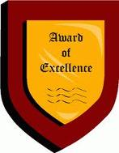

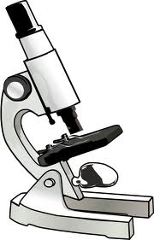

A great way to ensure your success and to meet new friends in high school is to get INVOLVED. If you are actively involved in your school, it is more likely that you will enjoy being there and be successful. Along with being fun, activities help to build your leadership skills.

Some options include:
  - Sports
  - Clubs
  - Band or Choir
  - ASB (class officer elections are held the 1st month of 9th grade)

Check out what your future high school has to offer by looking in the Planning Guide, talking to coaches and teachers, searching the high school webpage, making an appointment to talk to your counselor, or joining a student leadership group (they know what is going on because they plan school functions).

See your high school’s Planning Guide or website to find specific information about extracurricular activities.

KEY
It’s Time to Check your Understanding of
More KEY HIGH SCHOOL CONCEPTS

Directions: Answer each question. To assist, use the information covered on pages 23 - 39.

- Name one reason a student would take an online class: ___(see pg. 35)___

- A parent/guardian must excuse your absence with the school attendance office

within __2__ days of the absence.

- Will your freshman year grades count toward your cumulative GPA? YES NO

- What are the 3 major principles at Sequoia High School?

1. __personalizing___ 2. ___performance__ 3. ___choice ___

- Name 3 things you should know about changing your class schedule once school has started:
Changes to your schedule ONLY during the first 10 days of a semester, & ONLY if you have an error. If you drop a class AFTER 10 days you will receive an F for that class. You may not drop a class that is a requirement for graduation. You cannot change your schedule based on teacher preference, your lunch, or to get into a class with a friend.

1.

2.

3.

- What is the webpage for the Online HS program? www.onlinehs.net___

- Figure out the grade point average for the following grades and then figure out what the cumulative GPA will be:

A C B
A B B
B B A
A D F Cumulative GPA
3.75 2.25 2.0 2.67

- Your grade point average (_G_. P. _A__) is a number (the ___ average __ of all your grades) that reflects your academic performance.

- Name 1 extracurricular school activity you are interested in joining: (answers will vary)

- From the list on page 33, name 3 things you can do now to make sure you are ready for high school?

1. (See pg. 33)

2.

3.

KEY
The High School Cyber Hunt

Directions: Access your high school website to answer the following questions!

- The name of my high school is: Everett, Sequioa , Cascade, Jackson

- My high school mascot is: Seagull, Squirrel, Bear, Timberwolf

- My high school colors are: Purple/Gold, Silver/Black, Crimson/Grey, Green/Black

- My high school day starts at this time: 7:30 am (SHS’s start time varies)

- My high school day is over at this time: 2 pm (SHS’s end time varies)

- My high school principal’s name is: Lancaster, Shepherd, Woods, Peters

- My high school counselor’s name is: __(names will vary)______________

- My high school is located in this town: Everett, Everett, Everett, Mill Creek_

- My HS’s High School & Beyond family night is being held on: (See webpage)
(enter date)

- I look forward to getting more information about and/or joining the following two activities, sports teams and/or clubs:

  - ___________________________ b. _____________________________

- The exam that WA State requires me to pass is called the: Smarter Balanced Tests & Exit Exams
- The 2 college entry exams & their websites are:

Name _____ SAT__________ Website _ www.collegeboard.org__

Name _____ ACT___________ Website ____ www.act.org ________

- The most interesting thing about my high school is: _______________________

________________________________________________________________

- I need ___ 22 ____ of credits to graduate.
(number)

- I WILL graduate in the year of: ______2018______!

Webpage Resources

High School Websites:

Cascade High School: www.everettsd.org/Domain/8
CHS Counseling Dept: www.everettsd.org/domain/2025
Everett High School: www.everettsd.org/Domain/9
EHS Counseling Dept: www.everettsd.org/domain/2026
H. M. Jackson High School: www.everettsd.org/Domain/10
JHS Counseling Dept.: www.everettsd.org/domain/2027
Sequoia High School: www.everettsd.org/Domain/11
SHS Counseling Dept: www.everettsd.org/domain/2028
Online High School: www.onlinehs.net

High School Resource Websites:

Athletics: www.everettsd.org/Page/199
AVID: www.avid.org
Career & Technical Education: www.everettsd.org/Page/5958
Food & Nutrition: www.everettsd.org/Page/4827
Everett School District H.S. Graduation requirements
Policies: http://docushare.everett.k12.wa.us/docushare/dsweb/Get/Document-412/2410%20High%20School%20Graduation%20Requirements.pdf
Procedures: http://docushare.everett.k12.wa.us/docushare/dsweb/Get/Document-441/2410P%20High%20School%20Graduation%20Requirements.pdf
State Testing: www.k12.wa.us/assessment

Post High School Planning Websites:

ACT: www.act.org
Apprenticeships: www.lni.wa.gov/tradeslicensing/apprenticeship/programs/
Career Search: www.wois.org, www.myfuture.com
College Planning: See the College & Career Readiness link on each High School Counseling Webpage
College Board (SAT, AP, etc.): www.collegeboard.org
College Searches: www.collegeboard.org, www.fastweb.com, www.checkoutacollege.com,
www.questbridge.org/, www.projectopportunity.net/
Gap Year Fairs: www.usagapyearfairs.org/
Military: www.military.com
NCAA Clearinghouse: http://web1.ncaa.org/ECWR2/NCAA_EMS/NCAA.jsp
Scholarships: www.thewashboard.org. Also, under the College & Career Readiness link (on each High School Counseling Webpage), click on “Scholarships”
Understanding High School Credits
An Introduction Activity
8th grade

ASCA Standards: A:A3 Achieve school success, A:B1 Improve learning, A:B2 Plan to achieve goals

Purpose:
Students will understand the basics of the credits required for high school graduation and beyond.
- Identify the required credits and electives credits
- Record credits as classes are completed throughout the 4 years of an hypothetical high school
- Distinguish between credit requirements for attending a 4 year university after high school and credit requirements for high school graduation without attending a 4 year university.
- Be able to identify areas of concern and options if credits are not earned.

Materials needed:
Worksheet with the empty squares representing credit requirement
High school requirement pages from High School Guidelines booklet
Colored pencils

Lesson
- Start lesson by reviewing critical vocabulary: credits, electives, CTE Describe the number of classes needed to graduate from high school
  - 6 classes each semester so 12 classes a year
  - Show students that this is 48 semester classes (12 classes/year X 4 years) in high school
  - Share with students that they need to pass 44/48 or 11/12 semester classes each year.
  - You can let them know that a “D” is passing but will GREATLY impact their GPA.
  - Explain to student that they work they do in middle school prepares them for future learning and sets them up to pass their high school courses.

- Use overhead/document camera with blank worksheet.

  - Guide students through each year of high school and have them shade in half a box for each completed class (.5 credit for each class). You will need the graduation requirements from the planning guide for your reference.
  - Begin with freshman year and assume this “student” will pass each class. Use a specific color for each subject area: ex: math is blue, English is red, etc.
  - When the basic high school requirements have been shaded in (22 full boxes) – you begin to add options:
- additional classes for a 4 year university
- erase classes when credit are not received and discuss the so what happens with this – retake class, have freshman status again, summer school, credit recovery, etc.
  - An additional activity is to have students look at a sample transcript and shade in the classes that student completed for a look at what credits were received and what is still needed.

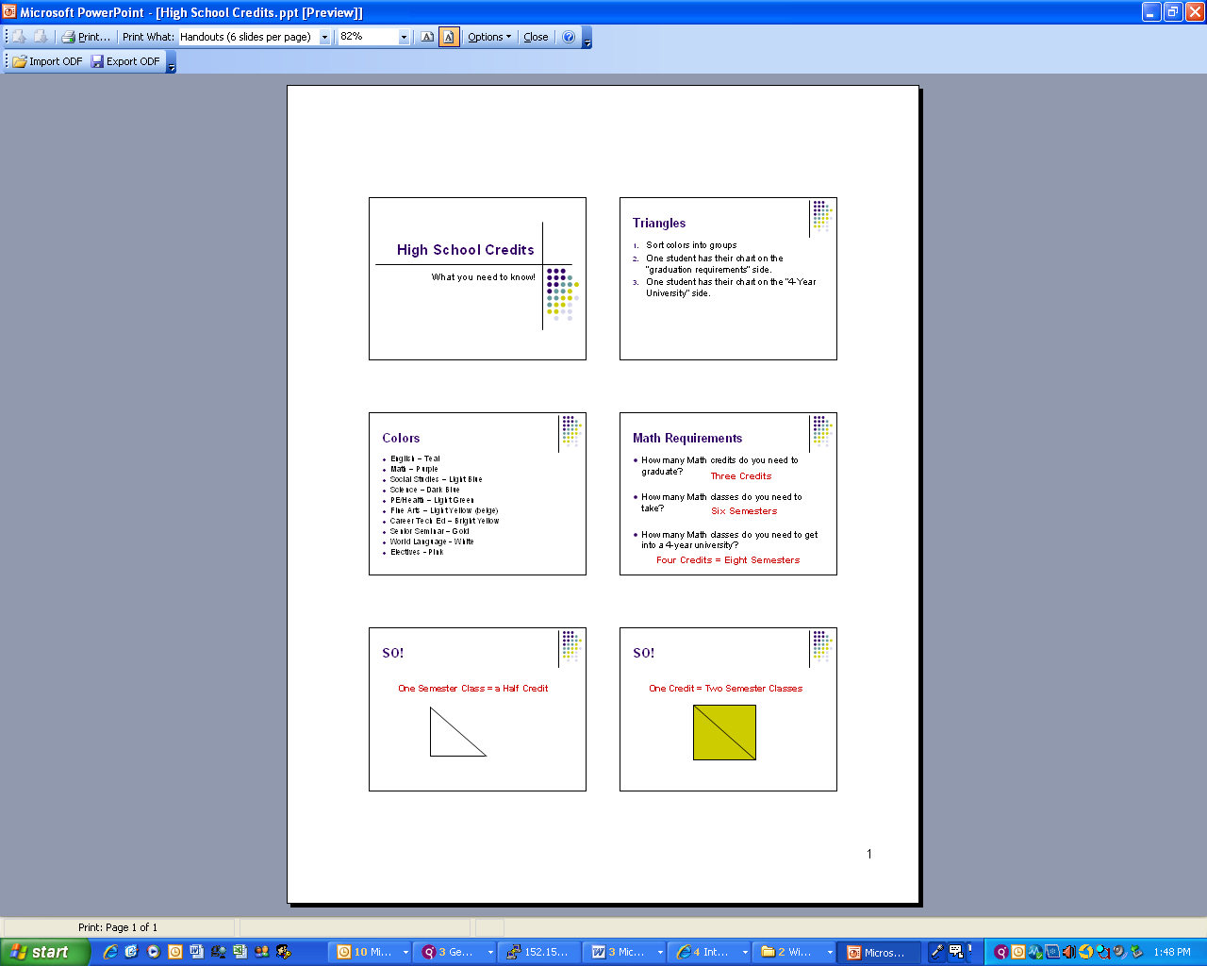
The above PowerPoint can be accessed within the District Counselor shared folder:
http://docushare.everett.k12.wa.us/docushare/dsweb/View/Collection-1432

Subject  4-Year University Requirements | Total Credits/Years Needed
English

Math

Social Studies

Science

PE/Health

Fine Arts

Career Technical Educ

Senior Seminar

World Languages

Electives

Name: ___________________________
Things to ________ before you go

Grades:
Freshmen grades ______ __________!
- Your grades throughout high school impact your future options.
- Your ________ does not start over each year.
- If you ______ a class, you don’t get any ______ and it _______ count toward your graduation. That failure ______ _______your transcript during your _______ high school career, _____ ____ you take the class over and get a better grade.

- Note: When you apply to college, the ______ you submit is often based on your first _____ years - 9th, 10th and 11th grade of high school. 9th grade or your freshman year is ___/___ of your GPA used when applying to college. Colleges ______ _____ your senior ________ and GPA as well, so senior year is also extremely important.

___________________:
There are important reasons to ________ your classes. Too many absences can cause the following:
  - Potential _______________
  - Inability to take ____________
  - _________ to participate in _______, ______-_____, _______ _________, etc.
  - ___________ to qualify for ________ __________

You need to be _____ class to ________. Get a pre-arranged absence form from the _______ website or ________ Office, fill it out, and turn it in to the Attendance Office before any planned absences. A parent/guardian must excuse your absence with the school attendance office within 2 days of the absence.

_________________ your Schedule:
  - You may make changes to your schedule _______ during the first _______ _________ of a semester, and _________ if you have an ________ on your schedule. See your school’s schedule change policy for more information.
  - If you ________ a class ________ 10 days you will receive an _____ for that class.
  - Make sure to _______ _____ _________ _________ if there is a problem with your schedule.
  - You _______ _______ _______ ___ __________that is a requirement for graduation.
  - You __________ change your schedule based on ________ __________, your lunch, or to get into a class with a _________.

______ for making your ______ count

- ________ friends who will help you ______. We ______ like the people we ________ _______ with.

- Sit close to the ______ of the _________ when possible.

- Ask __________! If you don’t ___________ something, chances are ________ in the class don’t understand either.

- Use the ________ _________ academic support time. __________ are available to help before & after school. The _________ is another perfect place to ___________.

- Learn to take good ____________ ___________.

- Learn to _________, _________, and ________ your written work.

- Study for ________.

- Turn off all __________ devices (TV, ______ ________, social _________ sites, _______ games, etc)! Students who ________ in more than an _______ or so of these activities ___ _______ put themselves at higher risk for __________.

- Find _______ adults. Find _______ adults ________ your immediate _______ to have as _______. Students who have ____________ adults, in addition to _________ to support them, do ___________ in school.

Get a_____ start on _____ School

Hey! There’s still ________ of time
to make sure you are ________

For the remainder of your ____ ________ year:

Make the rest of your 8th grade year_________. Start building your H. S. _______ now by:

- Completing work, _____________ in class, meeting _______ ________ and deadlines, and using a _____________r

- __________ and achieving _________. The skills you __________ by merely working on ________ will help you prepare for the _________ of high school.

- Joining a ________ or ______________ to help with a _________, _________ _________, or become a __________ mentor in a class.

- ___________ for help in your classes. The skills you are learning in 8th grade are a ______________ for your ______ grade year.

- Talking to your ____________ and __________ about registering for ________ __________ or honor classes in _______ grade.

- __________ the high school you will attend next year. ________ ______ functions that the high school offers for ____________ ____________.

- Taking _____________ classes to _________ up on your _______, _________ and ________ skills. You will use these skills in ______ class.

- Getting a _________ ________ and begin saving for activities in high school i.e. ___________, _______, _______ (it is NOT _____ _______ to start ________!)

List 3 things you _______ do to make sure you are prepared for high school:
1. _________________________________________
2. ______________________________________________
3. _________________________________________
Time Management
Adapted from www.collegeboard.com

It’s ______ pm ~ Do you know where your ___________ is and what you need to get done?

Do you ever feel like your _____________ running late, or do you _________ have _________ or __________ assignments? Does it seem like your day goes too ___________ and you run out of time to get everything __________? Here are a few tips on how to take __________of your time and __________ your life.

- Every day make a “_______ _______” list ~ whether it be on _________ or by using your ________ ________ calendar, list your __________ __________ tasks first.

- Use ________ time wisely. Waiting for your __________to pick you up? Have _________ time during lunch? Use any ________ time to _______ or study your _________ from the day.

- It’s _________ to say “________.” If you have an exam on __________ and have been invited to attend the ______________ game the _________ _________, you may need to ________ ________ if you haven’t already _________ for your exam.

- Find the _________time. Most people have a “________ time” to study ~ find your right time. For example, if you feel the most _________ in the afternoon, do your studying then __________ in the late evening.

- __________ _______ review your notes. This helps to __________ what you’ve learned, so you’ll need l________ time to study. This will also help if you teacher _______on you the next day or if there is a ________ _______.

- Get a good night’s ________. If you are ________ your day will seem longer and your _________will feel more _______.

- _____________ your _____________ with others. If your friends _______ you study from 4 – 5:30 pm, they’ll ________ to hold off on _________ ________ until _________ you’re _______ working.

- _________ your ____________. __________ _______ your _______ time, ________ your time and _______ activities accordingly

- Don’t ____________ time ________. Have you ever _________about an assignment or __________ all night long? Was it _______ it? __________ of agonizing and __________, just ________ it.

- Keep things in _______________. Set __________ goals – unrealistic ____________will set you up for __________. Set goals that are ____________ but ____________.
High School Planning Guide Scavenger –
Know Your Future

Directions: As you read your High School Planning Guide, answer all questions below; include the page number where you found your answer.

- In addition to earning credits, what two other things do you need in order to graduate?

b.

- What is the difference between a two year and four year college? Elaborate.

- How many years of training/school do I need in order to become a dental assistant?

- Identify 6 post high school opportunities.
a.
b.
c.
d.
e.
f.

- True or False: You must be a high school graduate in order to join the military.

- According to the 4 year plan, what subject must you take all four years of high school?

- What does the abbreviation AP stand for?

- What is one reason you would take an online class?

- Do you need a world language in order to graduate? YES NO

- How many credits do you need to graduate from a high school in the Everett School District?

- How many English credits do you need to graduate?

- What are at least 2 options for earning college credit in the high school?

a.

b.

- What 3 things do you need to know about changing your class schedule once school has started (in high school)?

a.

b.

c.

- Figure out the grade point average for the following grades and then figure out what the cumulative GPA will be.

A C B
A B B
B B A
A D F Cumulative GPA

- Will your grades your freshman year count toward your Cumulative GPA?

- What are the three major principles at Sequoia High School?

a.

b.

c.

- What are some things you can do NOW to make sure you are ready for High School? Identify at least 5.

a.

b.

c.

d.

e.

- What is one high school graduation requirement you can meet in middle school?
H.A.C. 4-year Plan Powerpoint Lesson

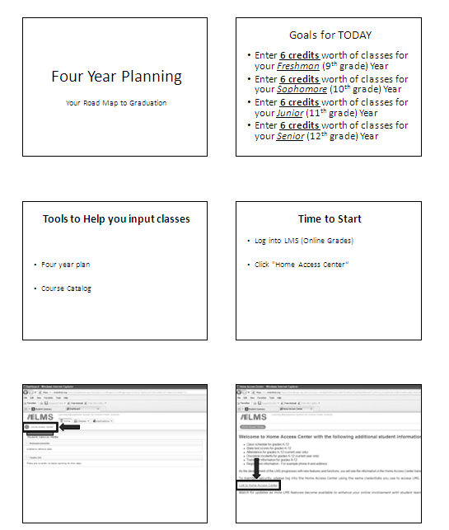
The entire above PowerPoint can be accessed within the District Counselor shared folder:
http://docushare.everett.k12.wa.us/docushare/dsweb/View/Collection-1432

